

  In This Issue
  3rd Annual Spin A Thon for ALS
  Warrior of the Month
  ALS Research News
  Tips from the Pros
  Photo Gallery
  Our Sponsors
  Team Blazeman members get great discounts from some of the best brands!
  
  Get your discounts today!
  For more information on Blazeman Warrior Discounts, contact Klong@waronals.com
  Make a donation today!
  Join Team Blazeman!
  The following is the list of registered Blazeman Warriors. We are proud to have you representing us on the battlefields!
  Clark Archibald
  John Mcnamara
  Kevin Perkins
  Melissa Merson
  Thomas Martwinski
  Jennifer Bornemann
  Kathleen Fetissoff
  Linda Laird
  Chris Ellinghaus
  Fabrice Le Det
  Petra Le Det
  Nick Logan
  Ran Korolik
  Erik Feeney
  Christopher Giordano
  Charlie Dunne
  Karen O'Riordan
  Mia Richter
  Jennifer Tebbetts
  Debbie Ragals
  Brian Breen
  Dru Bornhoeft
  Cheryl Iseberg
  Richard Volpe
  Christopher Price
  Alexander Ha
  Gregory Hoots
  Tricia Ryan
  Domnick Nelson
  David Knight
  Caryn Blanke
  Douglas Munsee
  Alexis Andrianopoulos
  Glenn Hines
  Philip Clark
  Susan Langevin
  Karen Duffy
  Mike Duffy
  Brian Duffy
  Kevin Long
  Steven Perunovich
  Sean Dutra
  Michael Ricci
  Cathy Ruf
  Ed Bullock
  Ryan Van Praet
  Doreen DiMeglio
  Judy Pratt
  Michael Keim
  Barbara Altemus
  April Colescott
  Gabe Fiscus
  Ken Fanelli
  Larry O'Connell
  Caryn De Filippo
  Jennifer Brady
  Diego Avalos
  Megan Knepper
  Brian Kochanek
  Paul Nowicki
  Ron Salmon
  Barry Conrad
  Christopher Demers
  Jennie Eddy
  Marty Peterson
  Jack Keenan
  Dennis Joyce
  Rob Duguay
  John Plumley
  Kimberly Magee
  Sean Waklee
  Christine Suter
  Collette Bates
  Brad Culp
  T. Connelly
  Michael Carr
  Richard Higgs
  Sean McNamara
  Jason Biggs
  Henry Hoyle
  John Purvis
  Leah Roberts
  Robert Maldonado
  Bill Peloso
  Shelley Farmer
  Michele Solomon
  Daniel Molloy
  Michael Ireland
  Michael Hicks, Jr.
  Leanda Cave
  Ryan Close
  Courtney Greene
  Thomas Simmons
  Colin Lake
  Tim Smit
  Jordan Bryden
  Kim Williams
  Chris Parker
  Shawn Mahoney
  Lisa Unger
  NEW WEBSITE DESIGN
  2007 saw the Blazeman Warriors donning a new look. Now the Blazeman Foundation for ALS is ROLLING with a whole new look for 2008. We are in the process of designing a new, interactive website where Blazeman Warriors can come to connect, and learn about upcoming events and the latest news on ALS research. Keep checking us out at www.waronALS.com.
  Blazeman Warriors,
  The start of a new year brings renewed energy and optimism as we fight this War on ALS. As we strive to meet our New Year's resolutions, let's resolve together to raise awareness and more funds for ALS research. Since online registration opened in June 2007, you have helped to raise nearly $200,000 for the Blazeman Foundation for ALS. It's exciting to see what you will do with a full year! We challenge you to pick a race or two as fundraising events; use your active.com webpage to reach out, share the story, spread awareness, and ask for support. Dare we say we can double or triple 2007's results? Could this be a million dollar year?
  Exciting changes are coming with the WarOnALS.com website, and 2008 Team Blazeman registration is open at active.com for those of you who still haven't done so online. Remember that we are racing for those who can no longer race-you are their arms to swim and their legs to bike and run. Continue to tell the world about ALS and wear your Team Blazeman uniform with pride - So Others May Live.
  strength & honor,
  Karen Duffy
  Blazeman Foundation for ALS
  3rd Annual Team Blazeman
  Spin-A-Thon for ALS
  By Shawn Mahoney
  VOLUNTEER HOSTS NEEDED!
  On Saturday, March 1st, 2008, we will continue the tradition started by John Wolski and crew by hosting the 3rd annual Team Blazeman Spin-A-Thon for ALS. This event will be held all over the United States and Canada, at various locations, hosted by Team Blazeman warriors. Over the past two years, both athletes and non-athletes have joined the cause to spin for the "War on ALS." Whether a Pearl Jam rocker, an Ironman champion, or an everyday person, this event has seen all walks of life get involved, volunteer, organize and most of all, spin!
  We need volunteers who are willing to host this year's event at a site of their choice, such as the local gym, community center, bike shop, school, or shopping mall. While hosting an event is a serious commitment, we are taking steps to make it as easy as possible. First, make the commitment to join our team by selecting a host location, or let us know you're interested and we will help you find that location. From there, it is all about planning, marketing, and reaching out to the local community. We have all the tools to guide you and help make it easy and fun.
  Once you let us know you're on board, we'll provide you with tips on selecting a site and how to market and run a successful event. This is a great opportunity for someone who wants to get involved to do so! We hope you all can join us on March 1st! To request more information or sign up as a host for the Saturday, March 1st, 2008 event, contact Shawn Mahoney at: Shawnmass2@comcast.net
  Be sure to visit the event's web site for more information at: www.spinforals.com . The site will be updated in the next few weeks with additional tools so visit often!
  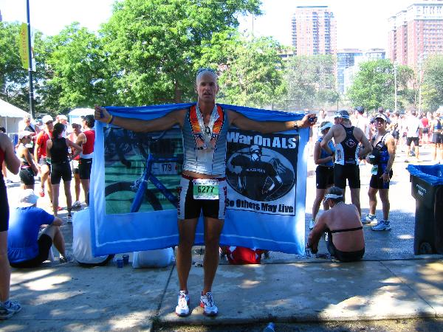
  Warrior of the Month-Jack Keenan
  By Karen Duffy
  I will not cross a finish line in the future on my feet. On June 4, 2007 these words came from Blazeman Warrior Jack Keenan as he joined Team Blazeman. Ever since then Jack has not only been true to his word but made a significant impact in the War on ALS.
  Jack is 42 years young and lives in Barrington, IL (a suburb of Chicago). He's a Principal of the Staubach Company, the world's largest Tenant Representation Commercial Real Estate Company headed by former Hiesman Trophy winning Quarterback for the Dallas Cowboys, Roger Staubach.
  I asked Jack how he got started in triathlon and here's what he had to say, I got started doing tri's in 1992. I was never a swimmer nor a biker. I showed up at the Accenture Chicago Tri (Formally the Mrs. T's and the worlds largest Tri) with no training under my belt, baggy shorts and no wetsuit. I swam the 1st 50 yards, almost drowned and actually walked a portion of the mile swim (wasn't a deep water swim) faking a swimming stroke. Needless to say, I was humbled, but hooked. It has been uphill since then. I raced a few International distance races every year and in 2006 did my first half IM and then in 2007 my first full IM in 12:17. I am determined to get to Kona by hook or by crook.
  Jack heard about the War on ALS after watching Jon Blais during the 2005 Ironman World Championship. I cried like a baby and will never be the same. What an inspiration! My neighbor, Bob Lee rode across the country in honor of Jon and when I followed him on his website, I was linked into the www.waronals.com . I recognized Jon's dad and sent him a message about wanting to get involved and then sent a second message to everyone linked to the site about wanting to roll across the finish line in Chicago in Jon's honor. I received a few responses saying Chicago was too congested and that it wouldn't be possible. From that moment, I was hooked. I not only rolled, but had a large flag made and carried it the last ¼ mile to the finish line and rolled with it. "Can't" isn't a word I like all that much and I figured rolling in a packed race like Chicago would get more attention. I promised Jon's dad I would never cross a finish line on my feet again, and will honor that promise. Crossing the finish line in IM Florida with a War on ALS battle flag is something I will never forget.
  Not only did Jack roll across that Ironman Florida finish line but he wore bib #179 the whole day and raised nearly $15,000 in the few weeks before the race! He used his active.com Team Blazeman fundraising page for online donations and targeted his fundraising letter to people he knew would spread the word and want to make a difference. He included the link to the You Tube video about Jon and asked his supporters to watch it. Jack said, While I would love to see my donations soar, I would rather you take ten minutes out of your busy day to watch Jon and learn something about a guy with incredible courage and determination. Well, they watched, were inspired, and donated $14,763.
  When I asked Jack what his goals were for the future he said, I will get to Hawaii. I have a wife and three kids under 7 which means I can't get too crazy with Ironman distances if I want to ever see my family. My number one goal in life is to be happy, and positively affect those that I come into contact with.
  Jack, you are reaching many people with your passion and dedication and it is an honor to call you a teammate in this amazing Team Blazeman family.
  T-dot Triathlon Athlete of the Year
  Jonathan S. Blais is the 2008 T-dot Triathlon Athlete of the Year. To read the article written by Jon's sister Jennifer Murphy click here.
  ALS Research News
  Possible ALS Drug Granted Orphan Status by the FDA (source ALS Association News, December 13, 2007) By Gary Wosk, Staff Writer
  A compound that could one day extend the lifespan of people living with an hereditary form of ALS, Lou Gehrig's Disease, has been granted orphan drug status by the U.S. Food and Drug Administration.
  Funding for study of second-generation antisense has been provided through The Association's TREAT ALS (Translational Research Advancing Therapy for ALS) program to study the potential effectiveness of the drug on primates.
  Approximately 5% to 10% of people with ALS have the hereditary form of the disease, called familial ALS. This approach targets the 2% of ALS carrying mutations in SOD1. Advancing this technology may have future implications for other forms of ALS as other abnormal proteins in the disease are discovered.
  Read more, click here.
  Turn the Off Season On
  Tips from Triathlon Pro Leanda Cave
  Happy New Year everyone. I'm not sure if it's just me, but 2007 went by sooooo quickly. I remember the winter----briefly, as before I knew it, spring came along, and I was getting stuck into my first races of the season. Well, it's that time of year again, and if you can
  relate to this, you know how important it is to start whipping yourself into shape for either your health or training purposes. So may I suggest for those of you preparing for a spring race, cut the 'crap', quite
  literally. I know I have over indulged on all that great festive food, and I am now wearing it! My rule of thumb is to stop adding sugar to my diet. So its 'au naturale'. Lots of fruit, lean meat, loads of veg, low fat cheese and milk, small meal portions, and no alcohol. I also
  recommend indoor biking. I have a lot of friends who love MTB riding in the winter, but it's not for me as I don't like the mud and rain. Get some good tunes on your MP3 player, and get creative with some good
  sessions. I usually do 90min workouts 3 times a week. The gym is another good place to be, as getting a solid, strong base using weights, is a great way to improve performance and prevent injury in the race season. Finally, keep it fun. Winter is miserable enough.
  www.leandacave.com
  Photo Gallery
  Just a few photos submitted by your teammates from
  recent events. Keep 'em coming!
  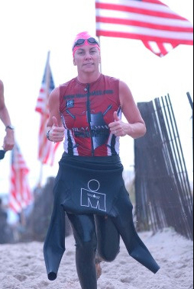
  Tricia Ryan exits the swim.
  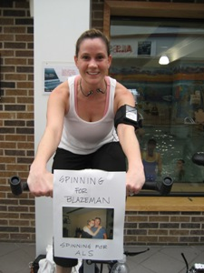
  Jill Martayand , at the 2006 Spin A Thon. Jill was Blazeman's neighbor in San Diego. She surprised Jon when she showed up at the Illinois event.
  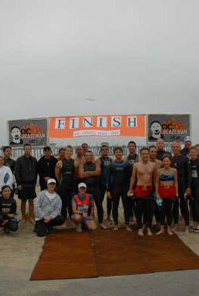
  2007 OC Blazeman, stay tuned for information on the 2008 event.

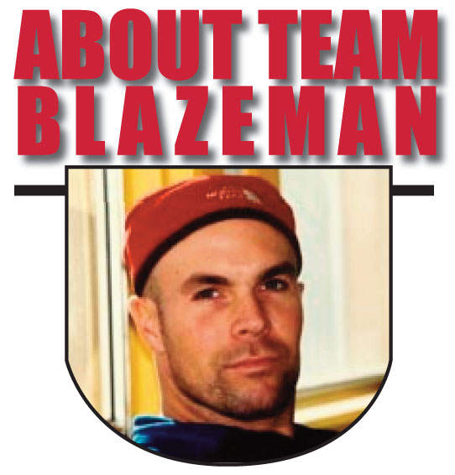
On May 2, 2005, twenty-year Multi-Sport veteran Jon Blais a.k.a. "Blazeman" at age 33 was diagnosed with the fatal motor neuron disease ALS (Amyotrophic Lateral Sclerosis). Blazeman dubbed himself the "ALS Warrior Poet" and brought his battle to the big island of Hawaii on October 15th that year, where he became the first person with ALS to complete the Ironman World Championships. It was his last race. In 2006, a number of athletes, inspired by Jon's 2005 efforts, rolled across the finish line in Hawaii in honor of Jon and his battle against ALS. In 2007, the Blazeman Foundation for ALS expanded Team Blazeman, comprised of "Blazeman Warriors" who have committed to raising awareness and funding a search for a cure for ALS... "So Others May Live."

Forward email
This email was sent to knduffy@bellsouth.net, by knduffy@bellsouth.net  Update Profile/Email Address | Instant removal with SafeUnsubscribe™ | Privacy Policy. | Email Marketing by  
War On Als | 20 Commerce Way, Unit 12 | PMB 283 | Seekonk | MA | 02771

